# Pycharm create Django project and connect Mysql

1. create a Django project with community Pycharm
2. Choose an adress and create django project

Scanf in Terminal: django-admin startproject Myfirstdjango

1. cd test1
2. Create app in django project

Scanf in Terminal: python manage.py startapp myapp

show like this:

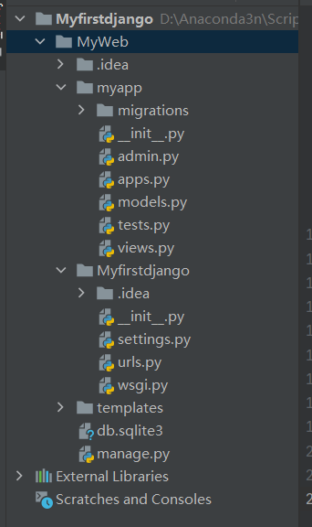

1. Start serverse

Scanf in Terminal: python manage.py runserver

Click 127.0.0.1:8000

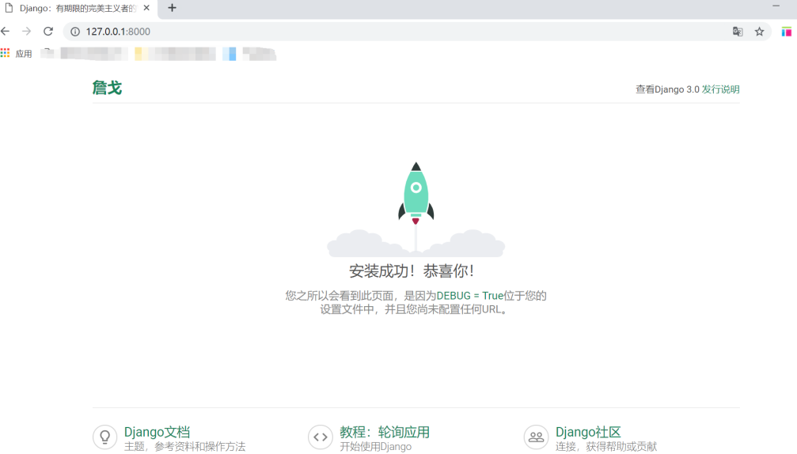

Successful!

1. Connect Mysql
2. create a database named testdjango by using Navicat

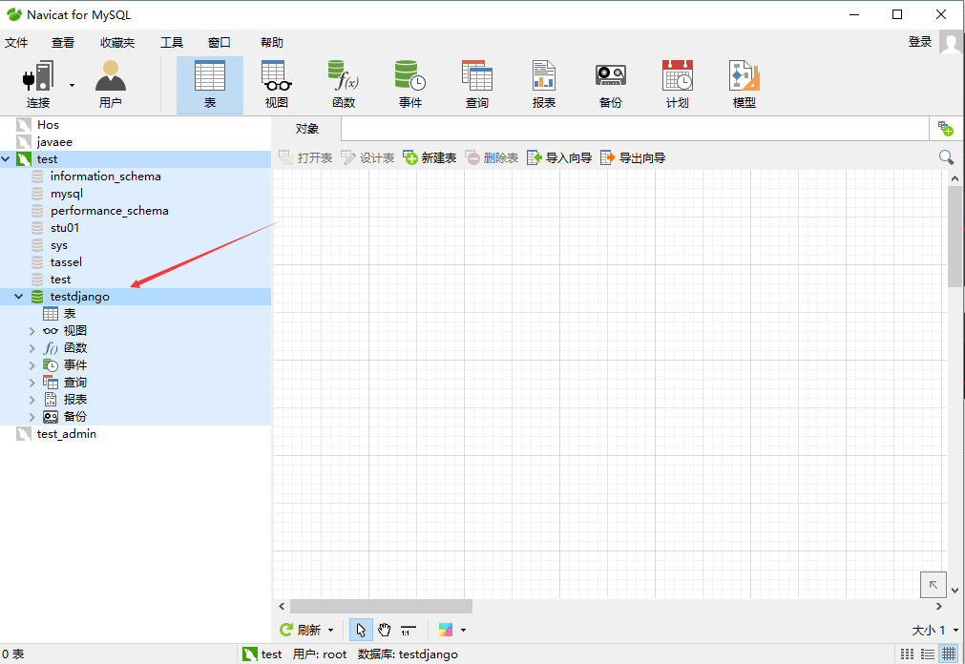

1. Install PyMySQL in Pycharm

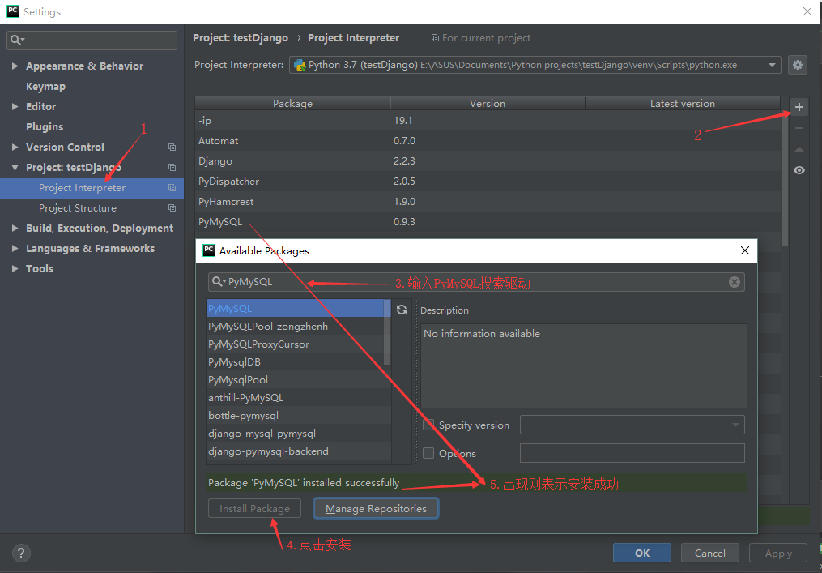

1. add codes in setting.py

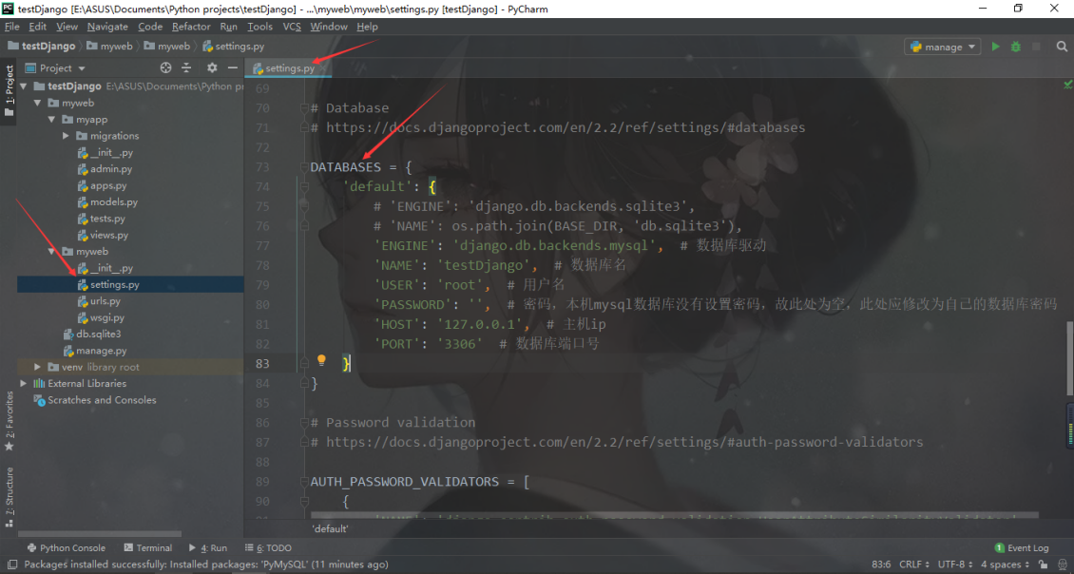

DATABASES = {  
  'default': {  
      'ENGINE': 'django.db.backends.mysql',  # 数据库驱动  
      'NAME': 'testDjango',  # 数据库名  
       'USER': 'root',  # 用户名  
       'PASSWORD': '',  # 密码  
       'HOST': '127.0.0.1',  # 主机ip  
       'PORT': '3306'  # 数据库端口号  
    }

1. Open _init_.py and add codes

import pymysql  
pymysql.install_as_MySQLdb()

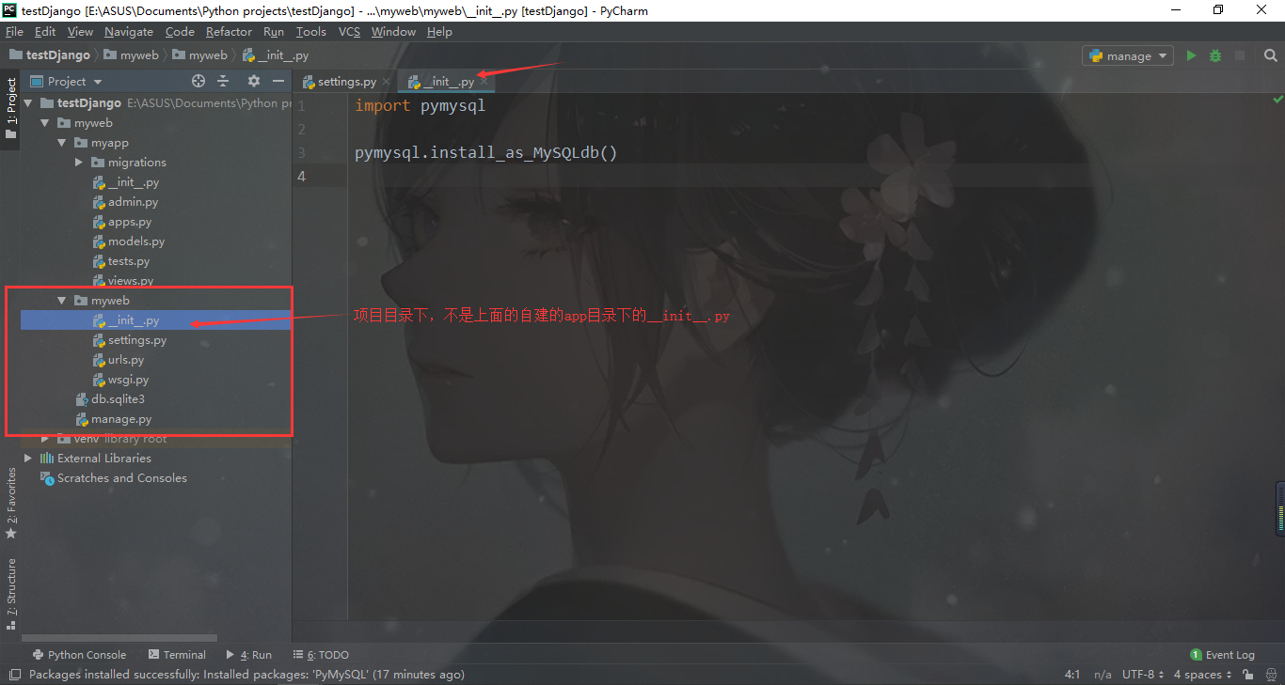

1. Correct mistake

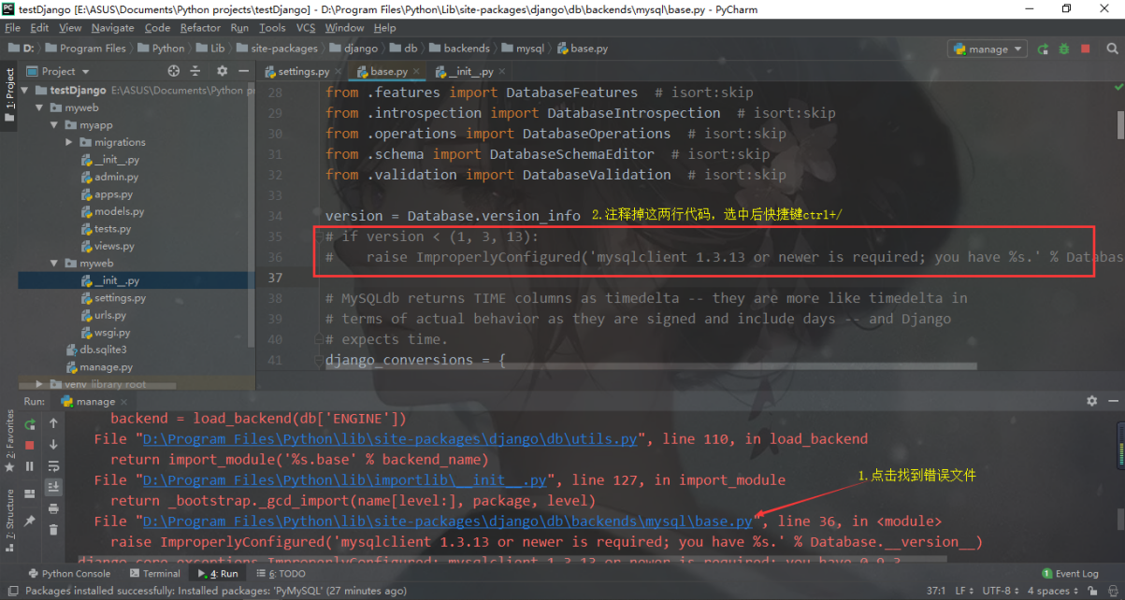

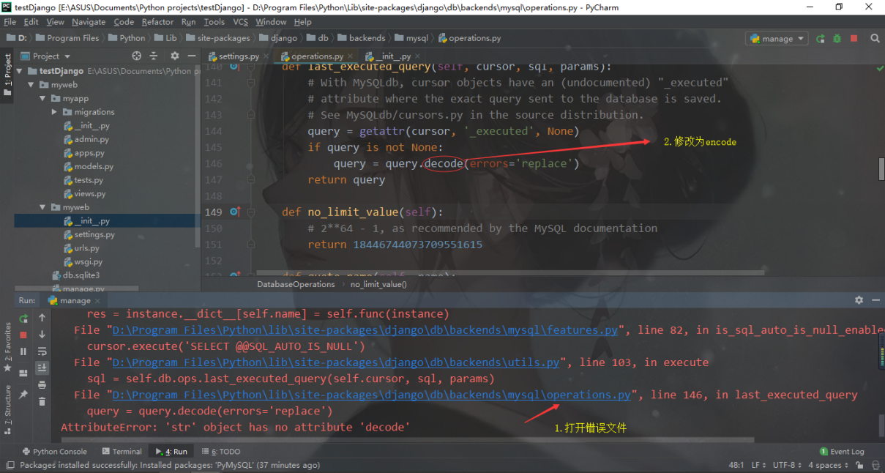

Successful!

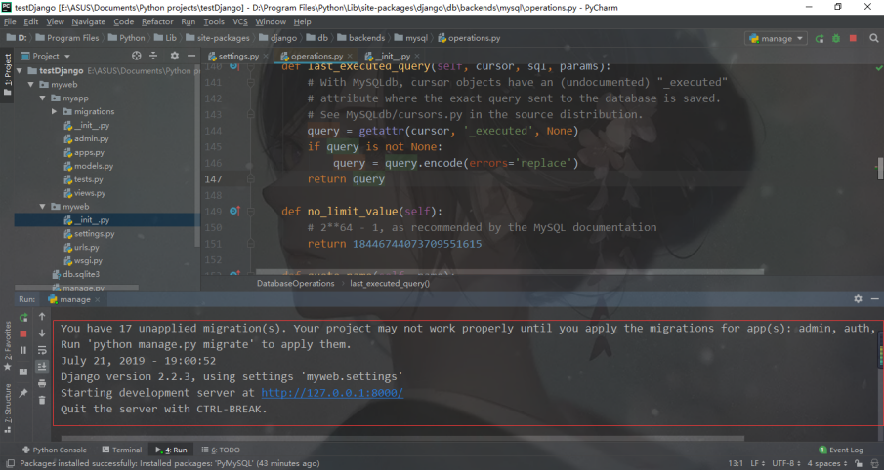

6)create database table model

Open APP’s models.py and add codes

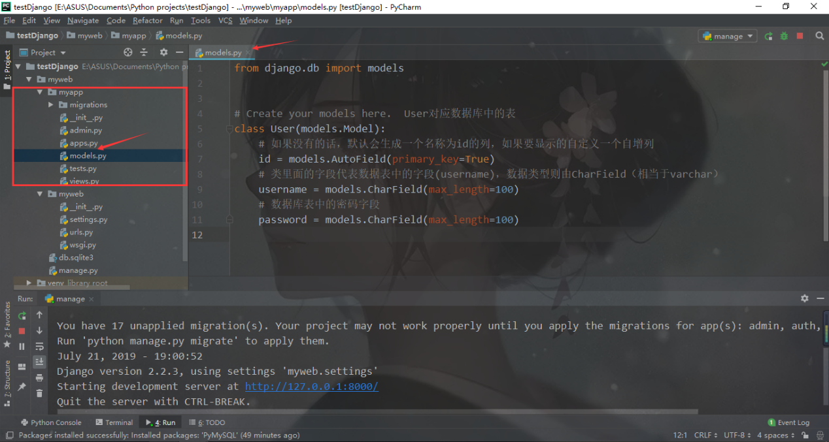

Add codes in setting.py

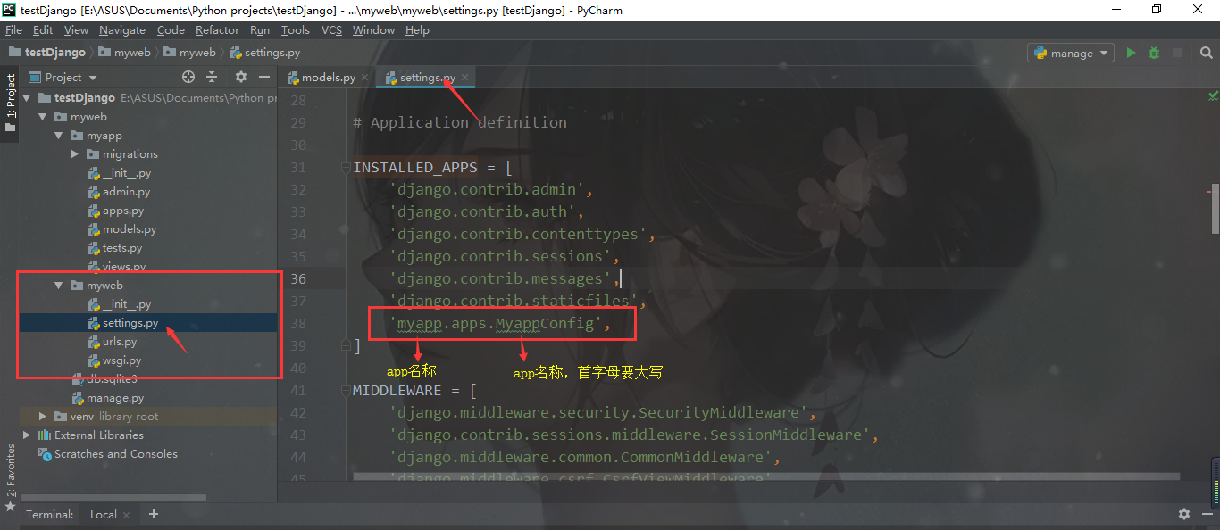

Successful!

